Name: P.Pallavi Regno: 192525448
Slot D – CSA1407 Compiler Design

CO3 AT1 – Experiment

- Syntax Directed Definition (SDD)

Aim
To evaluate arithmetic expressions using Syntax Directed Definitions (SDD) with synthesized attributes.

Procedure
  - Define grammar for expressions (E, T, F).
  - Assign synthesized attribute val to each symbol.
  - Apply rules based on operator precedence.
  - Evaluate expression step by step.
  - Display final computed value.

Output
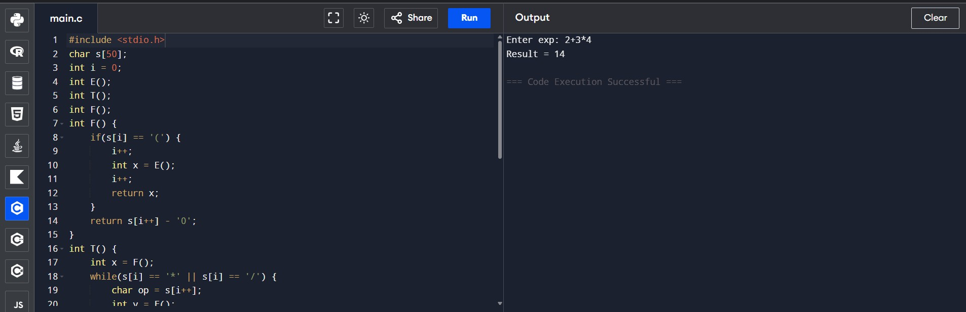

Postfix Evaluation (S-Attributed) Aim
To evaluate postfix expression using stack and S-attributed definition.

Procedure
  - Read postfix expression.
  - Use stack for evaluation.
  - Push operands into stack.
  - Pop operands when operator appears.
  - Perform operation and push result.
  - Final stack value is result.

Output
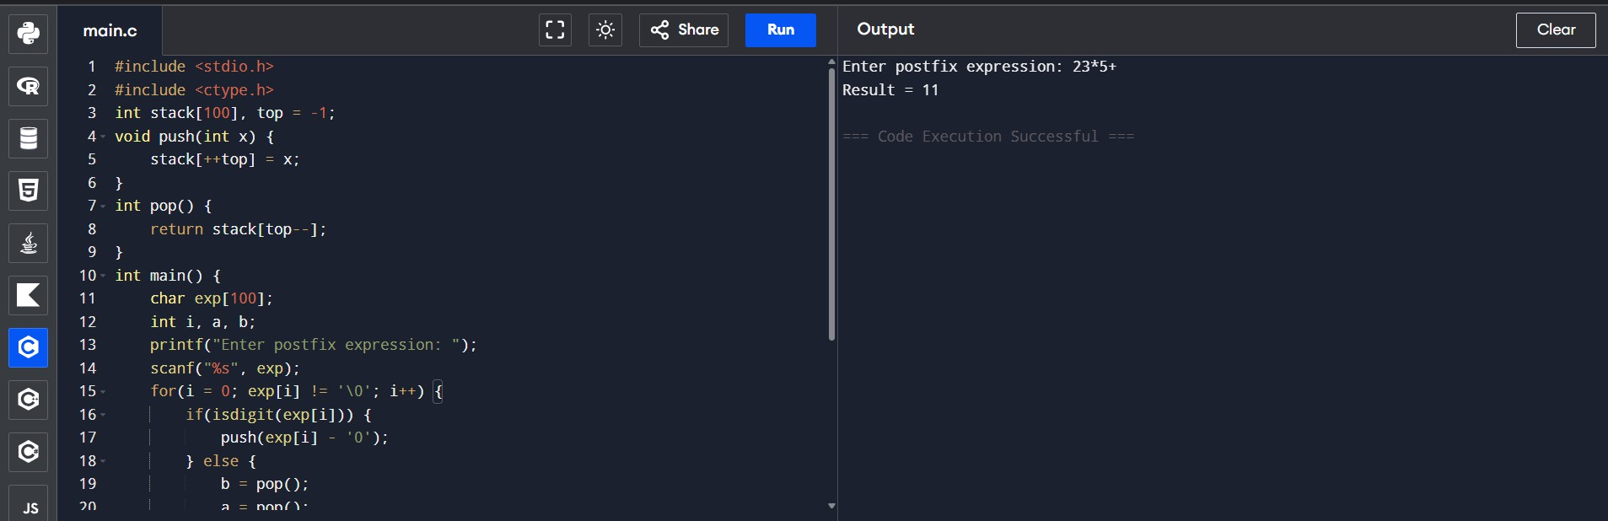

L-Attributed Definition Aim
To evaluate expressions using L-attributed definitions with inherited attributes.

Procedure
  - Use function parameters to pass inherited values.
  - Maintain operator precedence.
  - Evaluate expression in top-down manner.
  - Return computed result.

Output
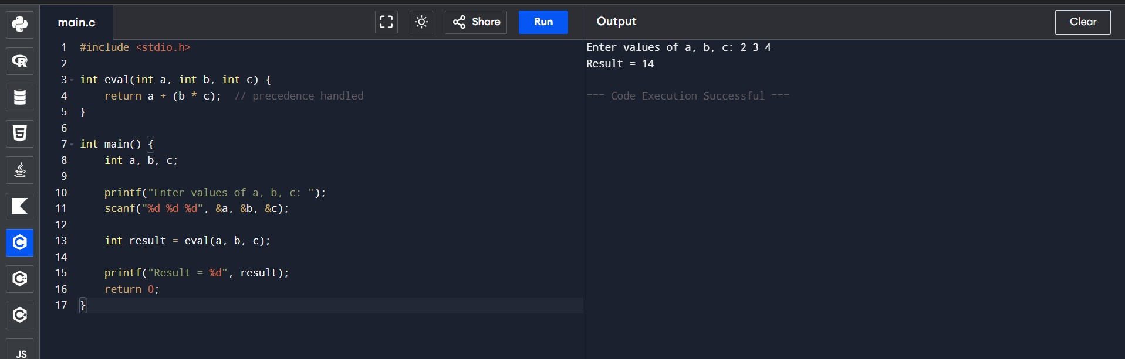

Type Equivalence Aim
To check whether two type expressions are equivalent.

Procedure
  - Accept two type strings.
  - Compare both strings.
  - Check pointer levels (*).
  - Display result.

Output
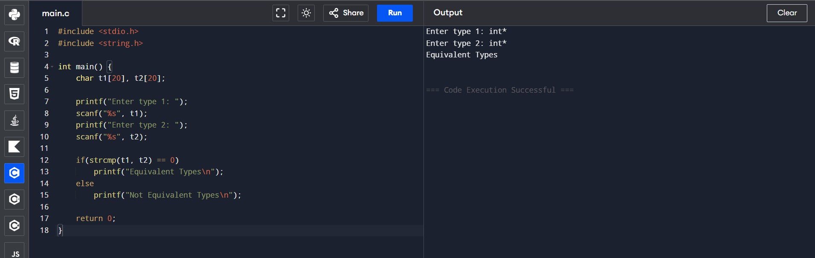

Type Checking (Semantic Analysis) Aim
To detect type errors in arithmetic expressions.

Procedure
  - Accept operand types.
  - Check compatibility.
  - Allow valid operations.
  - Display error for invalid types.

Output
